**Elastic IP Address**

* This is static public ip.
* Elastic IP is of no cost as long we are using it.
* If we allocate elastic ip to a ec2 instance and if we stop the ec2 instance then billing will start.
* Refer for pricing. (Link: <https://aws.amazon.com/ec2/pricing/on-demand/#Elastic_IP_Addresses> )

**NAT Gateway**

* NAT Gateway is NAT as a service offered by AWS
* Pricing of NAT Gateway 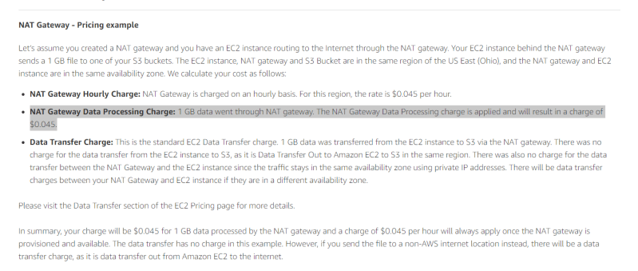
* Lets create a NAT Gateway and check connectivity 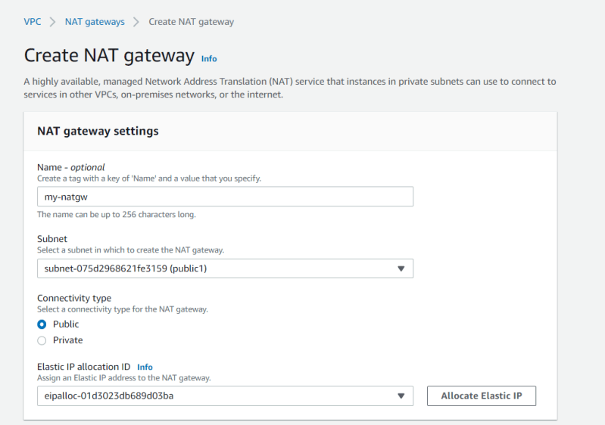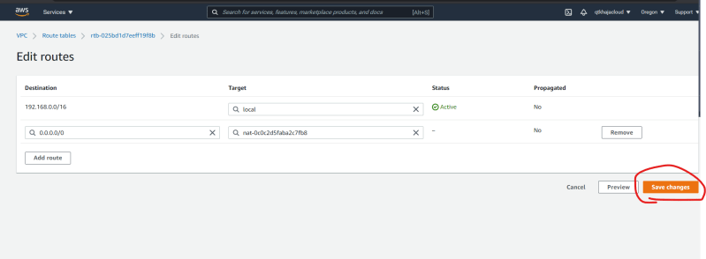
* To experiment with NAT Gateway, follow the steps as discussed in the class. 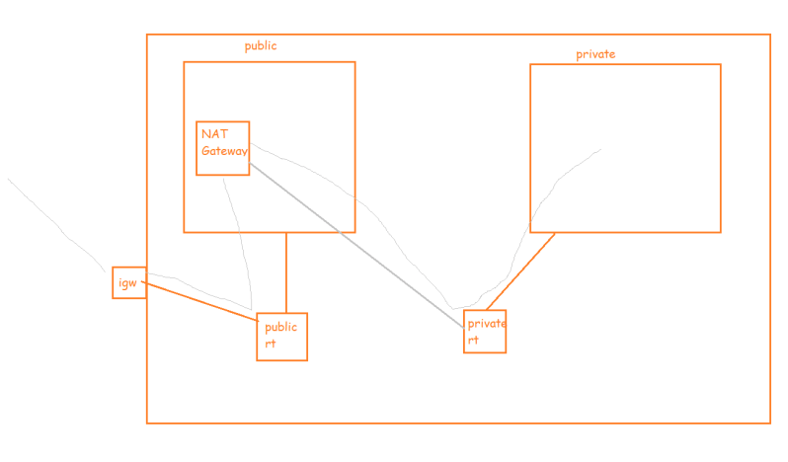

Internet gateway vs NAT:

NAT: Network address translator is used when instance in private subnet want to access the internet, but we don’t allow internet to access the instance.

Internet gateway: it provides two way communication between VPC and internet.